Thank You Driver - CPT's bus and coach driver recruitment campaign #ThankYouDriver

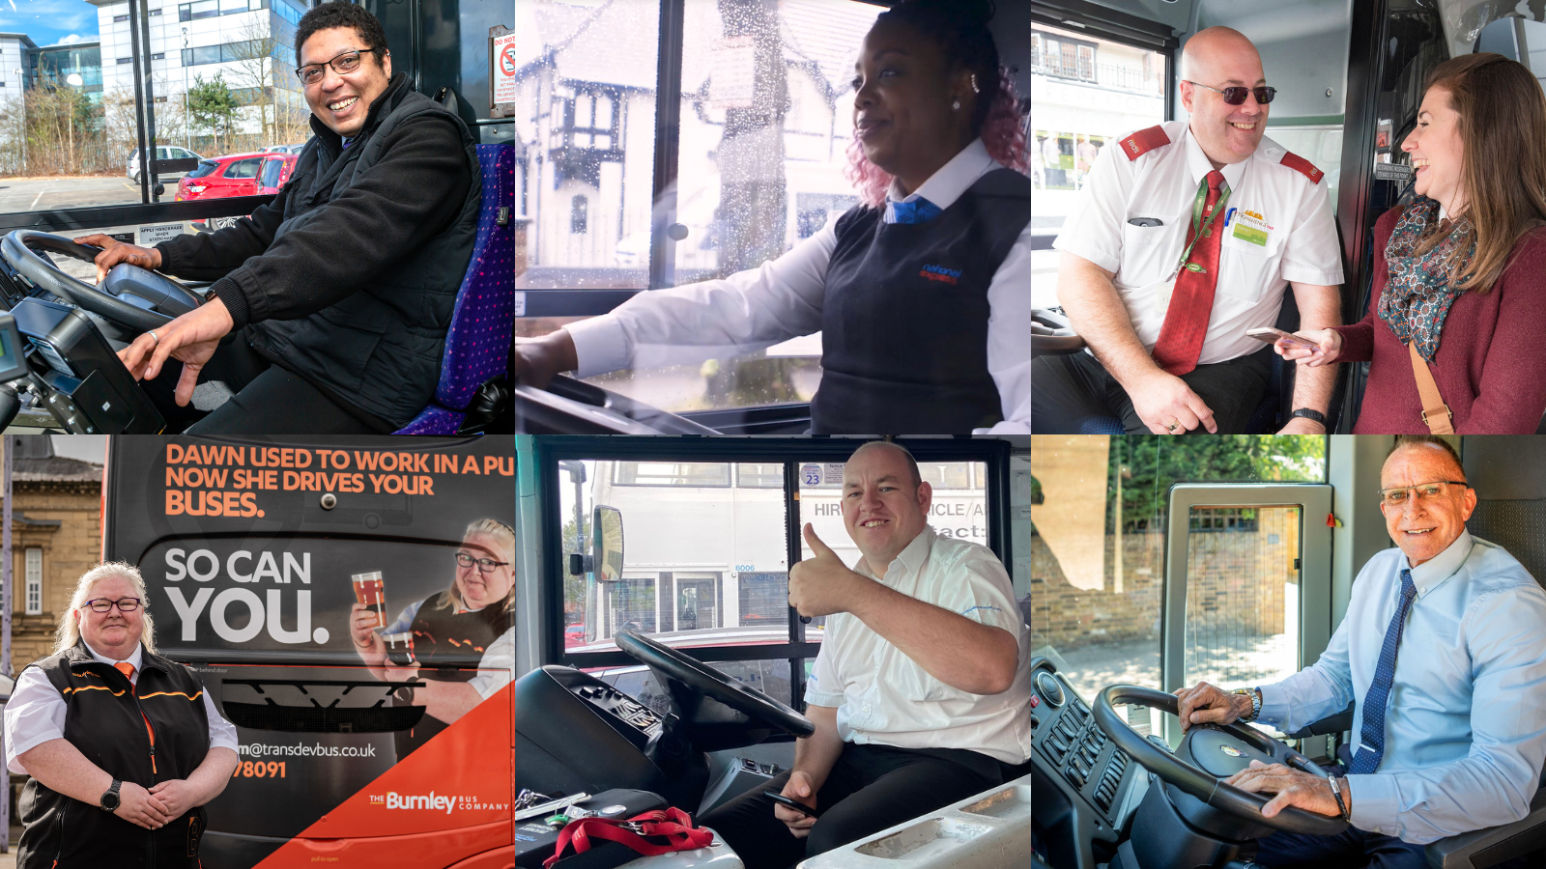
Pics above are via Uno Bus, National Express, Salisbury Reds, Transdev, Stanley Travel, Westway Coaches

CPT is launching a bus and coach driver recruitment awareness campaign on the 18th October. We hope all CPT members will get behind this initiative, not only to attract more drivers into the sector, but also to raise awareness of the great work drivers do every day in keeping local communities connected.

Our research has revealed that bus and coach drivers are the most thanked profession in the UK. As a result, our campaign is entitled Thank You Driver, or in Wales and the South West of England Cheers Drive.

CPT members can make use of the resources below, to spread the word on your social media channels and promote to your local media outlets.

Example social media posts:

Bus and coach drivers are the UK’s most thanked workers with 87% saying being thanked has a positive impact on their wellbeing. Visit thankyoudriver.org for more information on the latest vacancies in your area. #ThankYouDriver

Bus and coach drivers say meeting lots of different people, serving the community and getting people to where they need to go are amongst the highlights of their role. Visit thankyoudriver.org for more information on how you can join this rewarding sector. #ThankYouDriver

Bus and coach drivers are thanked more than any other profession in the UK according to latest research from @cpt_uk. Now you can join them, visit thankyoudriver.org for more information about how you can get involved. #ThankYouDriver

Infographics (Right click and select Save As)

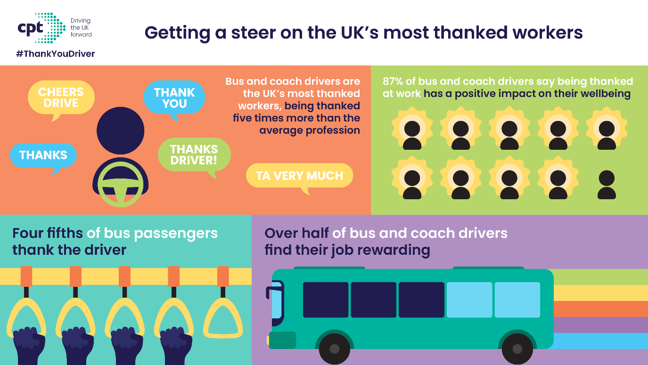
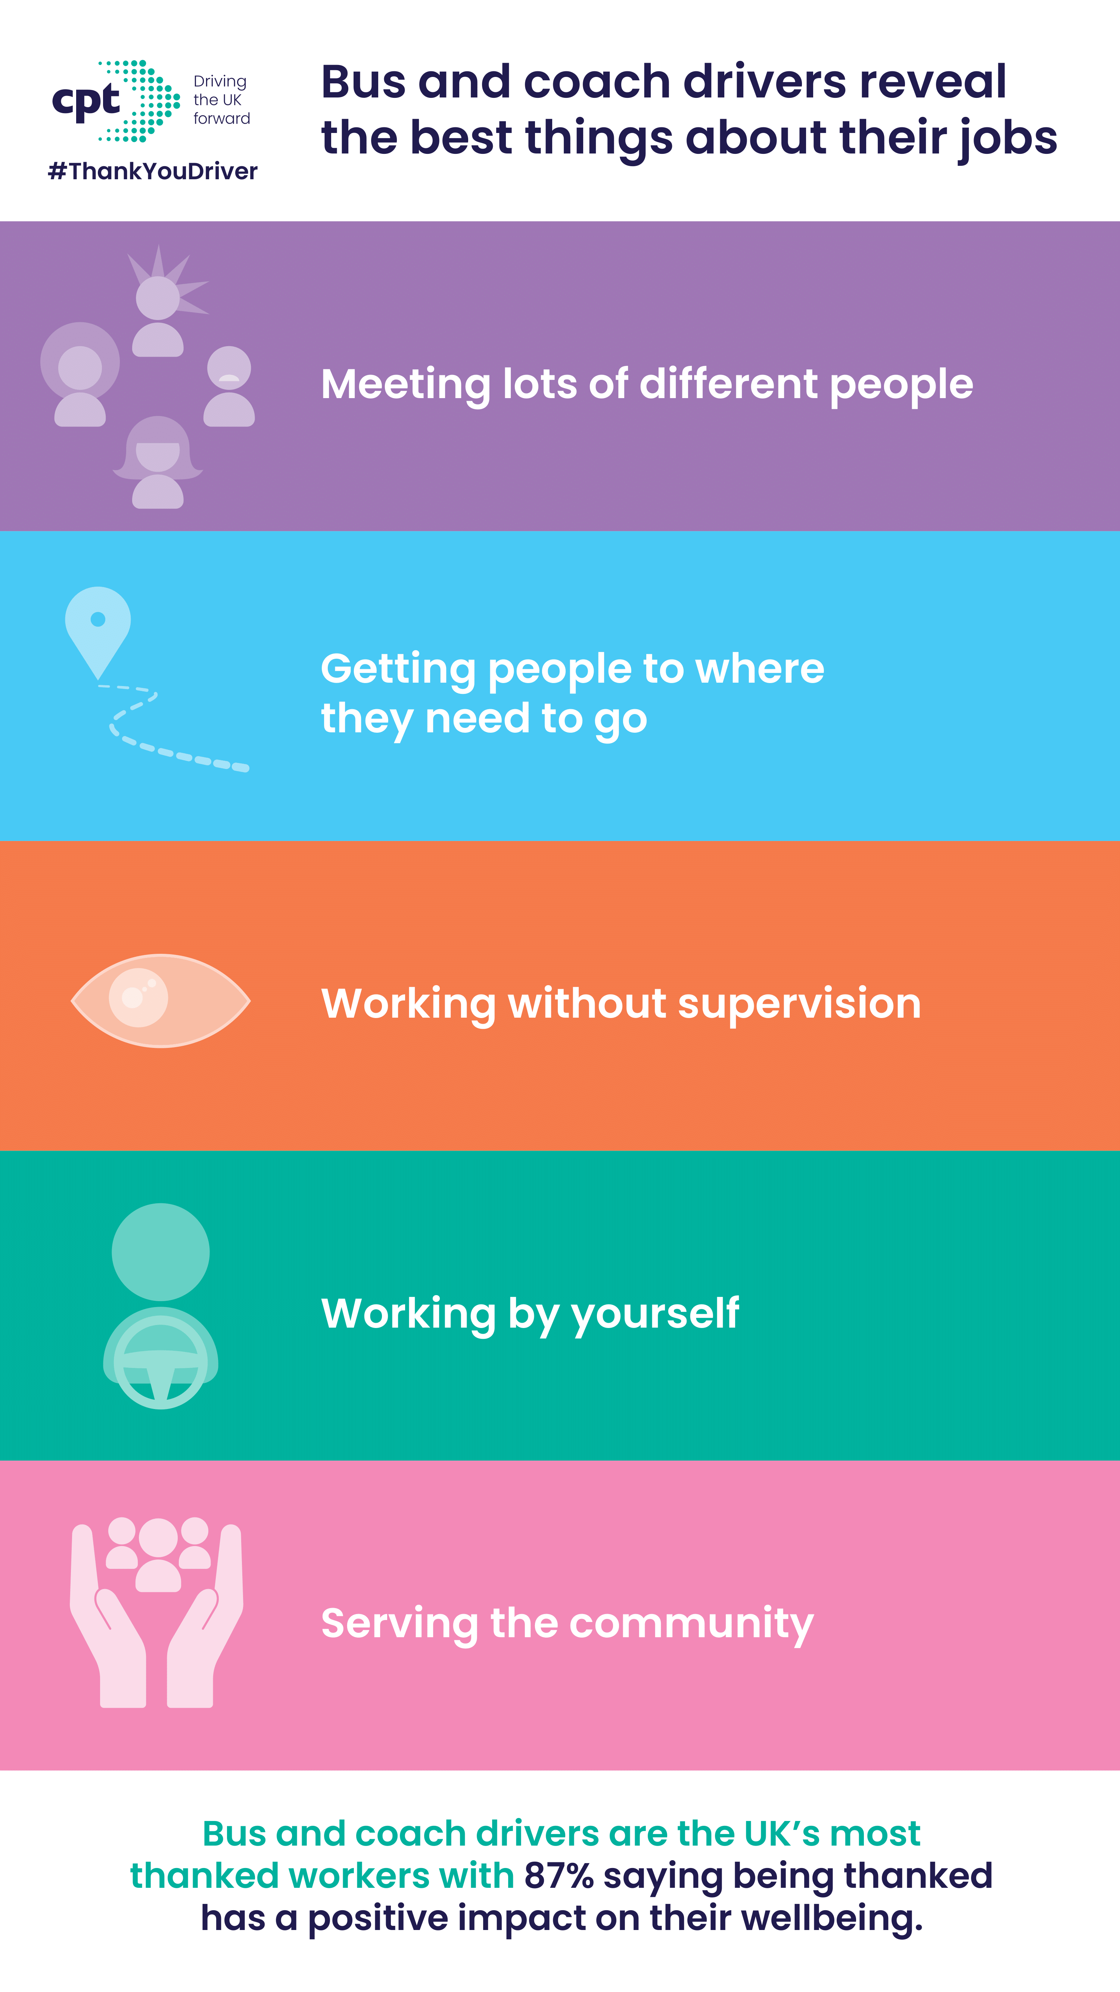
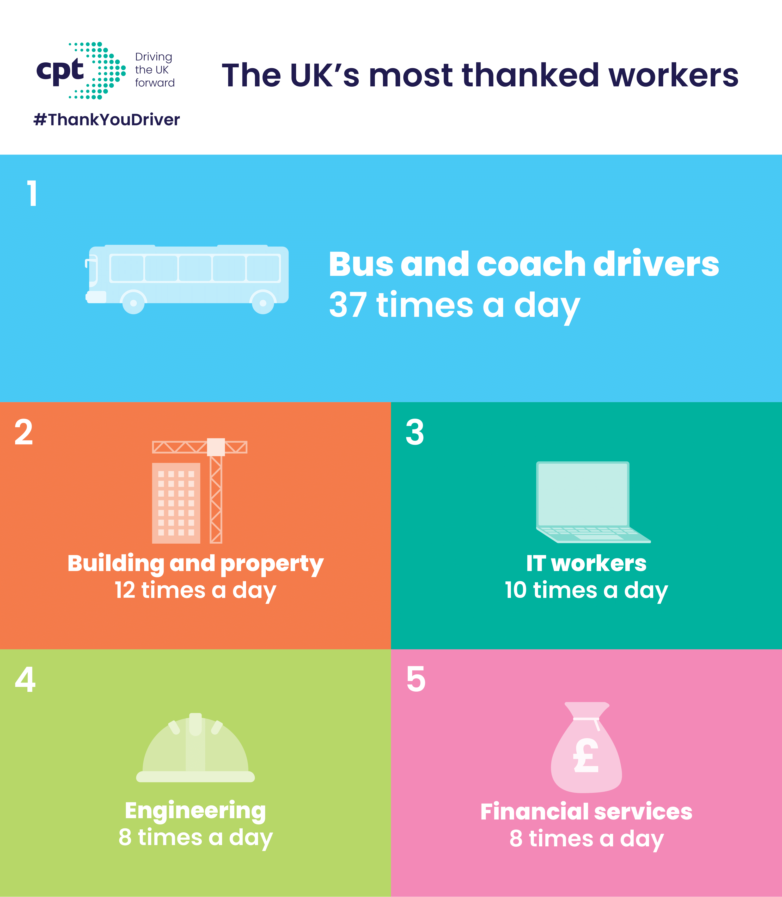

Example media release:

Bus and coach drivers, at companies such as Insert region’s Insert company here, have been revealed as the UK’s most thanked workers, receiving a thank you on average 37 times a day – five times greater than the national average.

Change statistics according to your region.

The Midlands and East of England lead the way in terms of the most thanked drivers with 89% of passengers thanking their drivers.

Other regions included:

- North East / West & Yorkshire: 86%
- South East / West: 84%
- Scotland / Wales / NI: 84%
- London: 70%

As many as four in 10 bus and coach drivers get thanked over 50 times a day; dwarfing other sectors like healthcare and retail where just 1% and 3% of workers are thanked 50 times a day respectively.

The research of 2,000 passengers and 1,158 bus and coach drivers also found four-fifths of Brits thank their driver, with nine in ten drivers saying a thank you positively affects their wellbeing.

The research commissioned by the Confederation of Passenger Transport as part of their Thank You Driver campaign, which aims to encourage more people to become a bus or coach driver.

CPT members Insert your company and company spokesperson here said: “Here at insert company name, our drivers pride themselves on keeping local communities connected and thrive on getting people to where they want to go. Being thanked plays a huge part in their role, and it is great to see such high levels of thanks for bus and coach drivers.”

Being appreciated was listed as one of the best things about being a bus or coach driver with over half saying they felt their work was rewarding – according to the research the role offers seven of the top ten things that UK workers value most.

These include meeting lots of different people; working without supervision; working solo; serving the community; being thanked and appreciated; good work life balance; and training opportunities.

Graham Vidler, Chief Executive of the Confederation of Passenger Transport said:: “It is never too late for those feeling unappreciated in their current profession to make the switch to become one of the UK’s most thanked workers. Especially given most bus and coach operators joined after working other jobs and the majority of the UK population possess a driving licence which will enable them to start training right away.”

To view and apply for available positions in your area as a bus or coach driver visit: www.thankyoudriver.org (If you are in Wales or the South West of England remove and replace with www.cheersdrive.org)

